Regulations:
A14

H.T No

Sreenidhi Institute of Science and Technology
(An Autonomous Institution)
Code No: 4C718 Date: 23-Dec-2019 (AN)
B.Tech IV-Year I-Semester External Examination, December - 2019 (Supplementary)
VLSI Technology and Design (ECE)

Time: 3 Hours Max.Marks:70

Note: a) No additional answer sheets will be provided.
b) All sub-parts of a question must be answered at one place only, otherwise it will not be valued.
c) Missing data can be assumed suitably.

Part - A Max.Marks:20

Answer all QUESTIONS.

1. | Distinguish Ion implantation from diffusion. | [2M]
2. | Find out the voltages at nodes P, Q and R. The threshold voltage, V_{th} is 1V.  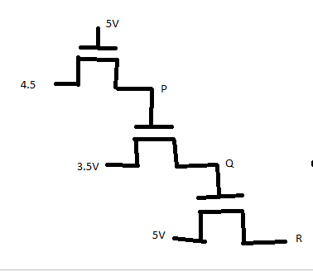 | [2M]
3. | Draw the stick diagram of CMOS inverter. | [2M]
4. | How do you calculate wiring capacitance? Explain. | [2M]
5. | Compare SRAM and DRAM. | [2M]
6. | What is controllability and observability? | [2M]
7. | List out the additional layers required in BiCMOS fabrication. | [2M]
8. | What are the benefits with scaling of MOS transistors? | [2M]
9. | What is the need for testing in VLSI Design? | [2M]
10. | Plot the transfer characteristics of CMOS inverter for various β ratios. | [2M]
Part – B Max.Marks:50
ANSWER ANY FIVE QUESTIONS. EACH QUESTION CARRIES 10 MARKS.

11. | a) | What is lithography? Explain Electron Lithography. | [5M]
 | b) | Explain the fabrication procedure of an NMOS transistor with neat sketches . | [5M]
12. | a) | Derive the relationship between I_{ds} and V_{ds} for an NMOS transistor. | [5M]
 | b) | How does the voltage swing vary with various forms of pull-ups? | [5M]
13. | a) | Draw a 4X1 mux using transmission gates. | [5M]
 | b) | Draw the lay out for an NMOS two input NOR. | [5M]
14. | a) | Estimate the inverter pair delays of both NMOS and CMOS technologies. | [5M]
 | b) | How does an off-chip load is driven by an inverter? | [5M]
15. | a) | Design a 4-bit barrel shifter. | [5M]
 | b) | Construct a 24-bit carry skip adder and explain. | [5M]
16. | a) | Explain in detail the Boundary scan architecture. | [5M]
 | b) | Discuss about the regular logic arrays. | [5M]
17. | a) | Explain the working of BiCMOS inverter. | [4M]
 | b) | Why NMOS is poor at logic level 1 and PMOS is poor at logic level zero? | [2M]
 | c) | Implement (A(C+D))’ in NMOS technology. | [4M]
18. | a) | Show that the sheet resistance of a slab is independent of the area of the square. | [3M]
 | b) | Explain Serial-Parallel multiplier with the aid of a neat sketch. | [4M]
 | c) | What is the Significance of fault coverage in testing? | [3M]

-- 00 -- 00 –

